# **Processor utilization factor and Schedulability analysis**

The processor utilization factor is a measure used in real-time systems to quantify the proportion of the processor's time that is being utilized by tasks. **It helps in determining whether the tasks can be scheduled to meet their deadlines.** The utilization factor is particularly important in scheduling algorithms like Rate Monotonic Scheduling (RMS) and Earliest Deadline First (EDF).

**Definition**

The processor utilization factor U is defined as the sum of the utilization of all tasks in the system. For a set of n periodic tasks, where each task Ti has a computation time Ci​ and a period Ti​, the utilization factor U is given by:

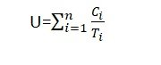

**Key Points**

1. Computation Time (Ci) : The worst-case execution time of task Ti.
2. Period (Ti) : The time interval between successive activations of task Ti.

**If the processor utilization is greater than one, then that task set will not be schedulable by any algorithm.**

**Schedulability analysis**

The processor utilization factor is closely related to *Schedulability analysis*, which is the process of determining whether a set of tasks can be scheduled to meet their deadlines under a given scheduling algorithm. Here's how the utilization factor plays a role in Schedulability analysis for some common real-time scheduling algorithms:

### Rate Monotonic Scheduling (RMS)

**Rate Monotonic Scheduling (RMS)** is a fixed-priority algorithm where tasks with shorter periods have higher priority. The Schedulability condition for RMS involves the utilization factor.

#### **Utilization Bound for RMS**

For n periodic tasks, RMS guarantees that all deadlines will be met if the total utilization U satisfies:

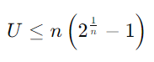

This bound is known as the **Liu and Layland bound**. As nnn increases, the bound approaches approximately 69.3%. If the total utilization is within this bound, the task set is guaranteed to be schedulable.

### Earliest Deadline First (EDF)

**Earliest Deadline First (EDF)** is a dynamic priority algorithm where tasks with earlier deadlines have higher priority.

#### **Utilization Bound for EDF**

EDF has a simpler utilization-based Schedulability test. A set of periodic tasks is schedulable under EDF if the total utilization U satisfies:



This means that EDF can fully utilize the processor up to 100%. If the total utilization exceeds 1, the task set is not guaranteed to be schedulable.

### Example: Schedulability Analysis

Let's consider a set of three periodic tasks with the following parameters:

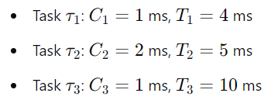

First, calculate the utilization factor U:

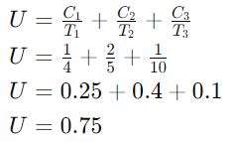

#### RMS Analysis

For three tasks (n=3), the utilization bound is:

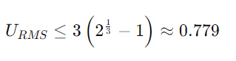

Since U=0.75≤0.779, the task set is schedulable under RMS.

#### EDF Analysis

For EDF, the utilization bound is simply:



Since U=0.75≤1, the task set is schedulable under EDF.

### Summary

The processor utilization factor is a crucial metric in schedulability analysis:

* **RMS**: The task set is schedulable if the total utilization is within the Liu and Layland bound, which depends on the number of tasks.
* **EDF**: The task set is schedulable if the total utilization is less than or equal to 1.

Utilization-based tests provide a straightforward way to check if a given set of periodic tasks can be scheduled to meet their deadlines under specific scheduling algorithms.